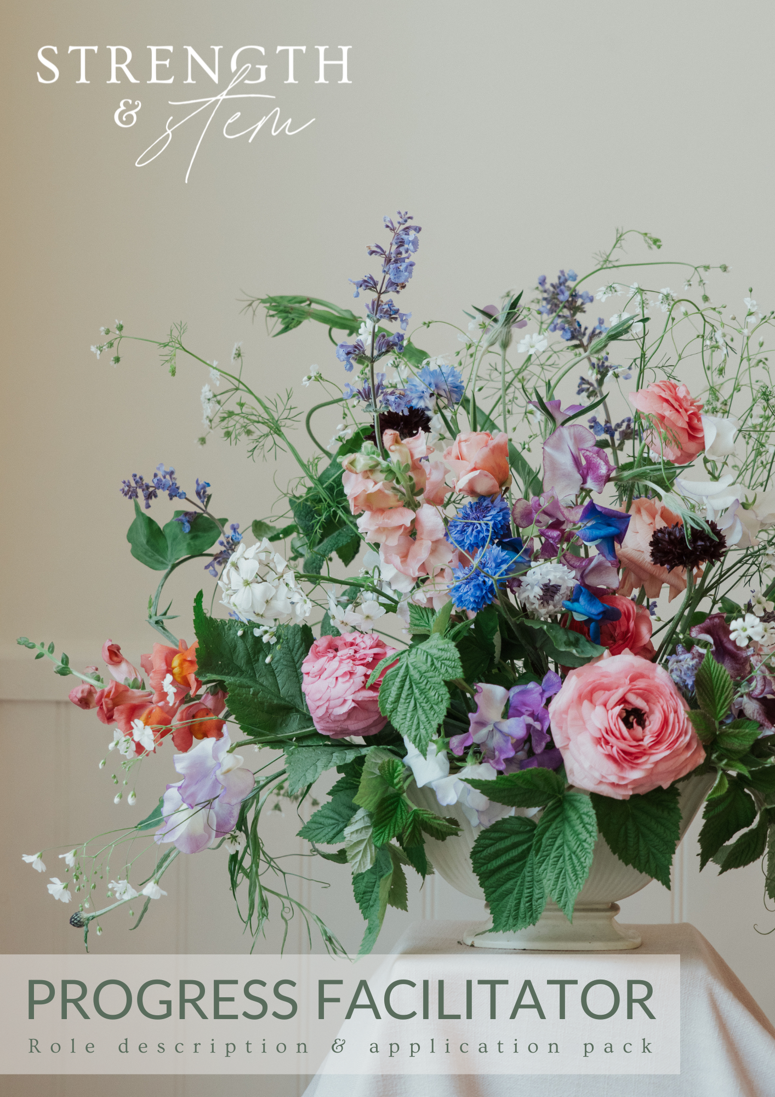

Strength & Stem: Progress Facilitator

ABOUT STRENGTH & STEM

Strength & Stem is a small charity and social enterprise that uses floristry to empower female modern slavery survivors. We want to see female survivors of modern slavery and human trafficking restored from their trauma, empowered for the future, and able to sustain a good quality of life. We achieve our vision by offering an evidence-based, holistic programme. It incorporates tailored skills training (including vocational floristry, prevocational and wellbeing skills training), work experience, mentorship, and a supportive community. We run an eight-month programme each year, as well as alumni events, and social cafes. The skills and experiences survivors gain through our programme creates a lasting difference for them and their families through economic independence, strengthened wellbeing and increased community.

The charity is growing its programme delivery team and recruiting a Progress Facilitator. This is an exciting opportunity for a dynamic individual to join a small, ambitious team, continually ensuring that our services are survivor-centred and have an impact positively disproportionate to the organisations’ age and stage of development.
TERMS
Role title: Progress Facilitator
Responsible to: Jenna Evans, Programme Director
Hours: One day per week (7.5 hours per week). This is a fixed term role for 12 months, with the possibility of extension and increased hours (funding dependant).
Salary: £28,000 pro rata (£5,600 per annum at 0.2 FTE). Reasonable programme-related travel expenses will be covered (this does not include accommodation).
Based: This is a hybrid role. You will be required to attend all programme related activities (including skills training sessions, social cafes, alumni events) and facilitate work experience placements in person. The workshops take place in London near King’s Cross and the work experience placements are currently in Chelsea and Windsor. There will be occasions where evenings or weekends are required but these are not often. You may also need to be available in London for ad-hoc meetings that require in person attendance. You must have the pre-existing right to work in the UK to be eligible for this role.
Current required in-person dates: As the Progress Facilitator, it is a requirement of your role to be present at programme related in-person sessions. The following are dates you will be expected to be on-site (this is not an exhaustive list):
- Workshops (Fridays): 3 May, 10 May, 17 May, 24 May, 31 May, 7 June, 14 June, 21 June, 28 June, 5 July, 12 July, 19 July
- Mentoring: 27 July
Due diligence: This role will require the Progress Facilitator to undertake a Disclosure and Barring Service (DBS) check and mandatory training.
Start date: 2 April 2024

This post is open to female applicants only as being female is deemed to be a genuine occupational requirement under Schedule 9, Paragraph 1 of the Equality Act 2010.

ROLE DESCRIPTION
At Strength & Stem we are working towards empowerment, restoration, and a good quality of life for our participants. The Progress Facilitators primary responsibility is providing specialist support for the individual progression of our participants through all aspects of the programme to ensure they get the most benefit and positive outcomes from their engagement in the programme. Under the supervision of the Programme Director, the Progress Facilitator has responsibility for the progression, support, and safeguarding of our programme participants. You will have a contributing role in ensuring every participant has a safe and positive overall programme experience. This role will involve working directly with survivors, as well as a wide range of stakeholders from supporting organisations to florists, volunteers, students, and the programme delivery team. You will need to be thoughtful, creative, methodical, and rigorous in your approach to progress facilitation.

KEY RESPONSIBILITIES
- Case Management and progression through the programme
  - Build trusting relationships with the participants.
  - Provide participants with individualised and holistic support to encourage engagement in all aspects of the programme (skills training, mentoring, and work experience), facilitate increased learning, and foster positive social connections.
  - Create an environment which meets that person’s needs and allows for individual progress.
  - Creation and tracking of needs, goals, and holistic progression plans.
  - Deliver or facilitate group skills training workshops, implementation sessions, and self-reflections which form part of the prevocational and wellbeing skills sessions.
  - Supporting engagement, participation, and reflection in floristry skills training sessions
  - Establishing the mentoring relationship and transition and participation in mentor scheme
  - Ensuring participants are settled and supported throughout work experience placement.
  - Liaise effectively with supporting organisations and other agencies involved in the care/support of participants.
  - Build relationships with local services relevant for signposting service users to and connecting women with opportunities in line with their support plan (e.g. specialist services, work experience, additional courses).
- Safeguarding
  - Respond quickly to safeguarding concerns, reporting appropriately to Strength & Stem Safeguarding Officer, following the safeguarding protocol, and supporting the individual appropriately through the process.
  - Regularly monitor risks associated with individuals you are supporting.
- Reporting and monitoring and evaluation
  - Keep detailed records of all case-working according to best practice and aide in safeguarding and monitoring and evaluation.
  - Assist the Programme Director in evaluating the services Strength & Stem offer through internal monitoring.
  - Contribute to the newsletter.
  - Writing relevant participant-related reports.

- Auxiliary services and alumni
  - Follow-up with alumni at regular intervals and through alumni events
  - Attend relevant auxiliary services and programme related events (for example social café)
- Contribution to service development and co-ordination
  - The development of services is the primary responsibility of the Programme Director, however, with your knowledge of participants and their experience you will be asked to provide valuable insight and your expertise of best practice to shape the way Strength & Stem operates.
  - The co-ordination of the services is the primary responsibility of the Programme Co-ordinator, but you will be expected to assist with any administrative and logistics tasks which are essential to the delivery of high-quality services.
Note: the specific distribution of the work hours to fulfil the role responsibilities across the programme delivery will be discussed with long-listed candidates.
PERSON PROFILE
Necessary:
- Due to the role responsibilities, it is a Genuine Occupational Requirement that this person is female (Schedule 9, Paragraph 1 of the Equality Act 2010).
- Right to work in the UK.
- Based in London or able to travel to London for in-person skills training workshops, work experience, alumni events, and social cafes.
- Have experience to utilise which would allow them to positively influence the independence, participation, and progress of the participants.
- Relevant experience with client group – female survivors of modern slavery and human trafficking, experiencing multiple disadvantages.
- Experience supporting an individual through safeguarding issues.
- Person-centred approach to support that is trauma-informed.
- Excellent communication skills, both verbal and written
- Organised with time keeping, record keeping, and communication.
- Have a kind, supportive and non-judgemental attitude, and approach.
- Hard working and able to learn new things quickly and prioritise learning and growth.
- Can work well independently but also enjoys working in a small team.
- Experience setting professional boundaries and investing in own mental wellbeing whilst supporting others.
- Agree to the staff code of conduct (see page 9).
- Be comfortable with our faith policy (see page 10).
Desirable:
- Qualifications in Health and Social care, Social Work, Support Work, Psychology (or other relevant qualification)/ mental health related disciplines
- Experience delivering group sessions and providing tailored individual support.
- Knowledge of the landscape of modern slavery, human trafficking, and the National Referral Mechanism
- Lived experience of disadvantage and/or human trafficking and modern slavery.
Progress Facilitator Application Form

IMPORTANT APPLICATION INFORMATION:

- Please send your CV and this application form (ensure to complete all parts) to recruitment@strengthandstem.com by no later than midnight, 18th March 2023.
- As we are currently recruiting for several roles, please ensure the subject line of your email is “Application – Progress Facilitator”.
- Please note that we review and progress applications on a rolling basis.
- The application process is as follows:
  - Submit your CV and application form.
  - Longlisted candidates will have an initial phone call with Jenna, Programme Director. This will be scheduled on a rolling basis as applications are received.
  - Shortlisted candidates will do a panel interview the week commencing 18 March.
  - Prior to the panel interview you will be asked to complete a brief role relevant task.

Please complete all parts of the application form below:

Personal details
Name |  | Date of birth
Telephone number |  | Email  address
Address
Postcode

Safeguarding
For the safeguarding of our women, we require all Strength & Stem staff to have a basic DBS. Do you have your basic DBS? |  |  |  | YES
 |  |  |  | NO
DBS number |  | Registration date

*If you do not have a DBS, you will be required to obtain one prior to starting. Strength & Stem will provide you with guidance on how to get your DBS and will cover the cost.

Personal details relevant to the role
How would you describe yourself?
Why do you want to do this role?
What is your experience of working with the service user group, female survivors of modern slavery and human trafficking, experiencing multiple disadvantages?
Give an example of a time you have supported a female to reach empowerment (economic, social, wellbeing) and independence.
Describe a time you have implemented a safeguarding procedure/policy to keep someone safe.
What excites and intimidates you about being a part of a programme/service delivery team at a small charity?
Is there anything else you would like us to know?

Disclosure information
Roles working with vulnerable adults are subject to a basic DBS disclosure; this will require you to disclose any criminal convictions which for other purposes are considered ‘spent’ under the Rehabilitation of Offenders Act 1974. Strength & Stem is an organisation that believes in second chances. This disclosure is for safeguarding purposes and will not necessarily affect your application
Do you have any convictions, or have you ever been in prison or a young offending institution? | Yes
 | No
If yes, please provide details:
Have you ever been disqualified from work with children or vulnerable adults or subject to any other sanctions imposed by a regulatory body? | Yes
 | No
If yes, please provide details:
We are committed to supporting women with a range of personal circumstances, including lived experience. If there is anything else of a confidential nature that you need to share with us that may affect your application/being a Progress Facilitator, we encourage you to provide this information below:

References
Please provide details of two references (referee should know you in a professional capacity for at least two years). By providing such details you are giving permission for us to contact your referees with the contact details you have provided. It is your responsibility to inform them that they will be contacted by Strength & Stem to provide a reference. Only referees of successful candidates will be contacted.
Referee 1:
Name |  | Job title
Company |  | Relationship to you
Email |  | Phone
Referee 2:
Name |  | Job title
Company |  | Relationship to you
Email |  | Phone

Progress Facilitator Application declaration
PRIVACY STATEMENT
- These details will be held in a retrievable electronic form.
- Personal paper records will be stored securely.
- Access to records will be limited to those who are entitled to see them as part of their duties.

DECLARATION

I declare that I have read the privacy statement and that the information given in this application form is true and complete.
Applicant Signature |  | Applicant name
Date
The information provided by you on this form as an applicant will be stored on a computer system in accordance with the Data Protection Act 1998 and will be processed solely in connection with recruitment.

Thank you for completing this form. We will be in touch regarding the outcome of your application either way.

Progress Facilitator Code of conduct and ethics

- The progression of the service users will be central to the Progress facilitator relationship – I will provide support and guidance to facilitate the service user’s independence and empowerment as they work towards employment, wellbeing, and social outcomes.
- I will interact with the service users only in the context of Strength & Stem’s services and related activities.
- I will provide a supportive environment within professional boundaries.
- I will be sensitive to the participants negative life experiences and present challenges and will treat them with unconditional positive regard, respect, and decency.
- I will be a positive role model for the service users, providing an example of professional conduct.
- I will keep the service user’s confidence to the extent possible without violating the law or safeguarding principles. If necessary, I will bring any issues of concern to the Programme Director, Jenna Evans
- I will attend safeguarding training with Strength & Stem and will always follow safeguarding procedures
- I will not share any details of the services or the service users with anyone outside of Strength & Stem
- I will keep in mind my commitment to always act in the best interest of the service users and Strength & Stem
- I will strictly avoid any impropriety, or appearance of impropriety, in my relationship with the service users and Strength & Stem
- I will never use derogatory terms, synonyms, or slurs or make inappropriate jokes. I will be especially sensitive to the life experiences of the service users, bearing in mind that they may have negatively experienced issues such as: human trafficking; rape; prostitution; crime; sexuality; faith/God; poverty; domestic violence; mental health; death.
- I will recognise my own limits and where necessary seek external advice or support.
- I will ensure that I have a good support system in place for my own wellbeing.

Note: The term services users includes both participants and alumni.

Faith Policy
Strength & Stem has a Christian ethos. Our work is motivated by God’s unconditional love, shaped by Jesus’ teachings, and inspired by the wisdom of the Spirit for the purpose of supporting female survivors of human trafficking as they begin to heal, gain independence, and experience true freedom.
Many of the Strength & Stem team hold a Christian faith, but this is not a requirement to work or volunteer for the charity, and it is never a requirement for the women we work with to benefit from our services. All are welcome to become part of the Strength & Stem community.
For anyone looking to work or volunteer with Strength & Stem we ask that you are sympathetic to our vision, mission and aims as we prepare female survivors of human trafficking for meaningful employment, using floristry as the tool. We also ask that any staff member or volunteer is respectful of faith views and is comfortable working within a faith-based organisation.
For the women we work with, our service is fully inclusive and non-discriminatory, maintaining respect for other world views and not passing judgement. All beneficiaries, regardless of the faith background they may or may not have, are treated equally and with wholehearted dignity and respect.

